Samsung Galaxy Tab S7 (Wifi, Wifi+LTE).
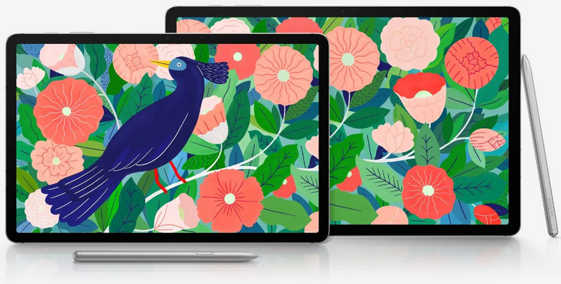
Dimension:253.80 x 165.30 x 6.30
Weight:498.00gm
Battery:8000mAh
Snapdragon 865
16 MP + 5 MP
Adreno 650
Super AMOLED, 1600 x 2560 pixels
128 GB and 6 GB or 256GB and 8GB

Screen size (inches) | 11.00
Resolution | 2560x1600 pixels
Pixels per inch (PPI) | 274

63999.00 + 14000 (keyboard)
Review: Great device for creative tasks with additional keyboard can provide desktop like experience.

Pro: 5G Connectivity

Pro: Solid Processor And RAM

Pro: High-Quality Camera

Pro: Crystal Clear Audio

Pro: Expandable Storage

Pro: Updated Stylus (Included)

Pro: Great Battery Life

Con: LCD Instead Of OLED

ALIENWARE m15 GAMING LAPTOP
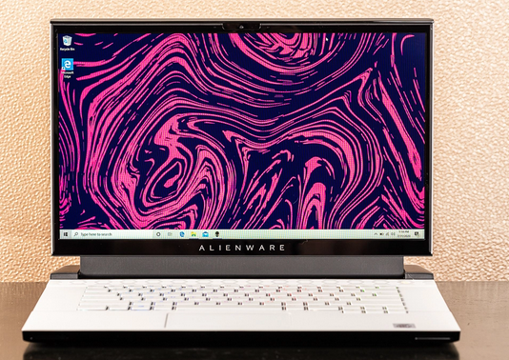

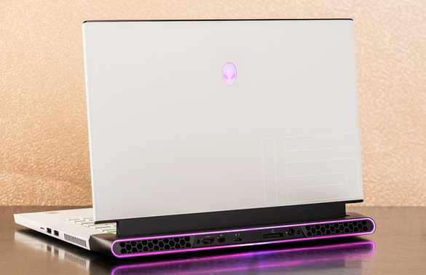

- 10th Generation Intel® Core™ i9-10980HK
- NVIDIA® GeForce® RTX 2080 SUPER™ 8GB GDDR6 with Max-Q Design
- 32GB DDR4 2666MHz
- 4TB (2x 2TB PCIe M.2 SSD) RAID0 [Boot] + 512GB PCIe M.2 SSD [Storage]

Other variants:
10th Generation Intel® Core™ i7-10750H
NVIDIA® GeForce® GTX 1660 Ti 6GB GDDR6
NVIDIA® GeForce RTX™ 2060 6GB GDDR6 (OC Ready)
NVIDIA® GeForce® RTX 2070 SUPER™ 8GB GDDR6
AMD Radeon™ RX 5500M 4GB GDDR6

1 x Power/DC-in Port
1 x RJ-45 Killer™ Ethernet E3000 10/100/1000Mbps/2.5Gbps Port
2 x Type-A USB 3.1 Gen 1 Port
1 x Type-A USB 3.1 Gen 1 Port with PowerShare technology
1 x Thunderbolt™ 3 Port (USB Type-C™ with support for USB 3.1 Gen 2 10Gbps, 40Gbps Thunderbolt, and DisplayPort 1.2)
1 x Alienware Graphics Amplifier Port
1 x HDMI 2.0b with HDCP 2.2 Output Port
1 x Mini-Display Port 1.4 (certified) Output Port
1 x Audio Out 1/8" Ports (Compatible with inline mic headset)

1 x Wedge-shaped lock slot (cable and lock sold separately)
1 x microSD 5.1, UHS-II HD312 Card Reader
Height (rear): 0.768" (19.5 mm)
Height (peak): 0.807" (20.5 mm) with OLED or 144Hz displays [ 0.783" (19.9 mm) for the 300Hz display]
Height (front): 0.807" (20.5 mm) with OLED or 144Hz displays [0.704" (17.9 mm) for the 300Hz display]

Depth: 10.87" (276.2 mm) with OLED Display
Depth: 10.86" (276 mm) with Non-OLED Display

Width: 14.19" (360.3 mm)

Lowest weight: 4.65 lbs (2.11 Kgs)^{i}
Maximum weight: 5.5 lbs (2.5 Kgs)

Based on Alienware's Legend industrial design language
Engineered with Alienware's Advanced Cryo-Tech Cooling technology
Engineered with Hyper Efficient Voltage Regulation
Constructed with a Magnesium Alloy exterior shell and copper alloy thermal components

4-Way (Woofer/Tweeter) Stereo Speaker Design
Introduces Discrete Smart Amp Woofer technology
Delivers 2.5x bass improvement over previous generation
Delivers 2x treble improvement over previous generation
Delivers 30% loudness improvement over previous generation for full range performance

Killer™ Wi-Fi 6 AX1650 (2x2) 802.11ax Wireless and Bluetooth 5.1
Review: Not worth it as next generation graphics card available at lower cost.

HP ENVY x360 Laptop - 13-ay0045au
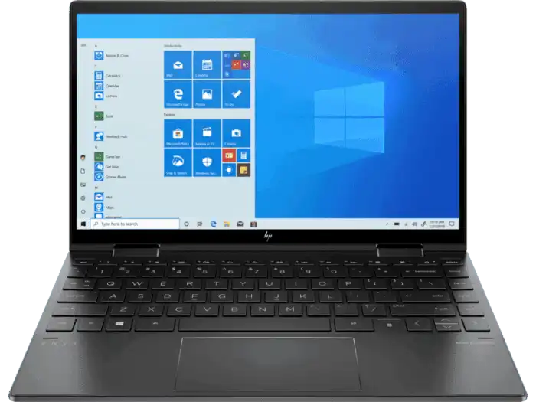
AMD Ryzen™ 5 4500U (2.3 GHz base clock, up to 4.0 GHz max boost clock, 3 MB L2 cache, 6 cores)
8 GB DDR4-3200 SDRAM (onboard)
512 GB PCIe® NVMe™ M.2 SSD
33.78 cm(13.3) diagonal FHD, IPS, BrightView, micro-edge, WLED-backlit, multitouch-enabled, edge-to-edge glass with Corning® Gorilla® Glass NBT™, 400 nits, 100% sRGB (1920 x 1080)

AMD Radeon™ Graphics
1 SuperSpeed USB Type-C® 10Gbps signaling rate (USB Power Delivery, DisplayPort™ 1.4, HP Sleep and Charge); 1 SuperSpeed USB Type-A 5Gbps signaling rate (HP Sleep and Charge); 1 SuperSpeed USB Type-A 5Gbps signaling rate; 1 AC smart pin; 1 headphone/microphone combo
microSD media card reader
30.65 x 19.46 x 1.64 cm
2.42 kg
₹79,999
Review: Good specifications. Additional Ram can be expanded to 32 gb in 2 slots.

Acer Nitro 5 AN515-44
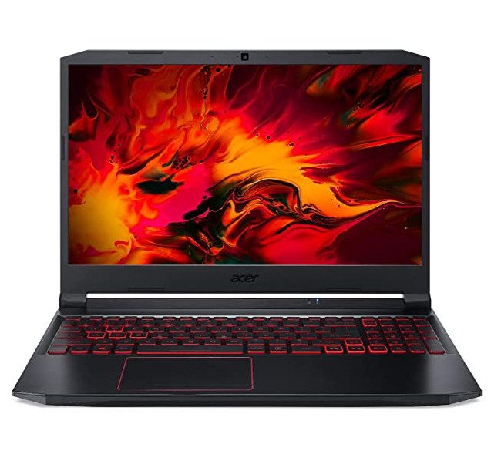
- 2.5 GhzGHz Intel Intel Core i5-10300H processor 10th Gen processor
- 8GB DDR4 RAM
- 1TB 7200rpm hard drive + 256GB SSD
- 15.6-inch screen, NVIDIA GeForce GTX 1650 Graphics
- Windows 10 Home 64 bit operating system
- 10 hours battery life, 2.3kg laptop
- Processor: Intel Core i5-10300H processor, turbo up to 4.5 Ghz | Display: 15.6" display with IPS (In-Plane Switching) technology, Full HD
- DTS X:Ultra Audio, featuring optimized Bass, Loudness, Speaker Protection with up to 6 custom content modes by smart amplifier
- Warranty: One-year International Travelers Warranty (ITW)
- Memory: 8 GB of DDR4 system memory, upgradable to 32 GB | Storage: 1 TB HDD 7200RPM + 256 GB SSD| Graphics: NVIDIA GeForce GTX 1650 with 4 GB of dedicated GDDR5 VRAM

25.5 x 36.3 x 2.6 cm; 2.3 K
69999/-
Review:

